PSALMS 23
HE MAKETH ME LIE DOWN IN GREEN PASTURES
Written By: Tommy Romans January 2016

Psalms 79:13 - So we the people and Sheep of thy pasture will give thee thanks for ever: we will show forth thy praise to all generations. Give ear O Shepherd of Israel, thou that leadest Joseph like a flock.
Psalms 95:7 - For He is our God; and we are the people of his Pasture, and the Sheep of his Hand. God always referred to himself in the Old Testament as the Shepherd of his people. When we come into the New Testament Jesus calls Himself the Good Shepherd and we are the sheep of his fold. He redeemed us and brought us into this good fold by the price of His own Blood. Peter refers to Jesus as the Chief Shepherd and Bishop of our souls. Paul refers to Jesus as the Great Shepherd. I am so glad I have a keeper and guide! I truly seek no other. I placed myself in His hand a long time ago and He brought me into the greenest pasture! Can I tell you that He is good? He satisfies the longing soul and fills the hungry soul with goodness. I thank you my dear Jesus: I am staying with you and will never ever think about leaving your good pasture and the comfort of your fold!!
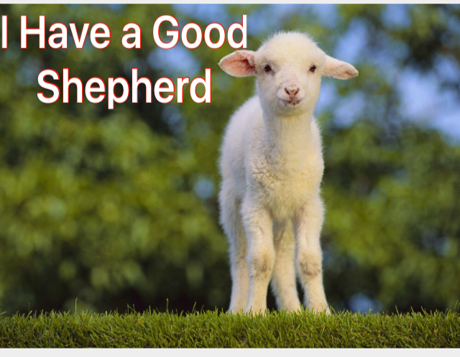
We brought out in the last newsletter that this Psalm was written by David over 3030 years ago and it is just as rich and true and inspiring now as it was when he penned it. We found that sheep require more special care than any other class of livestock. They cannot take care of themselves! They can’t even guide themselves nor defend themselves. The very characteristics of sheep is, it’s not bold or smart as a lion, it’s not even as strong as a dog nor swift like a deer. When it goes astray, it does so sometimes for no reason at all and it cannot find its way back home. O the helpless state of man without God! Children, we need Him now more than ever. “Keep me O God as the apple of thine eye. Lead me, guide me, keep me from evil and give me your peace!”
We also brought out that sheep will not and cannot lie down in green pastures until four

requirements are made. We covered the first two, which is, # 1 - they must be free from Fear and # 2 - they must be free from Friction. Now let’s look at
# 3 -

FREEDOM FROM TORMENT

Keller said through his many years of experience, that sheep will not have peace if they are tormented by parasites and insects. Sheep, especially in summer can be driven to absolute distraction by nasal flies, bot flies, warble flies and ticks. When tormented by these pests, it is literally impossible for them to lie down and rest. Instead they are up and on their feet, stamping their legs, shaking their heads and rushing off into the bushes for relief. Phillip Keller said that only the diligent care of the owner who keeps a constant lookout for these insects will prevent them from annoying his flock. A good Shepherd applies various types of insect repellent to his sheep. He will see to it that they are dipped to clear their fleece from ticks. He said it takes considerable extra care and expensive chemicals. He said, “Every day I had to keep a close watch on their behavior. As soon as there is the least evidence that my sheep were being disturbed, I had to take steps to bring them relief. Always uppermost in my mind is to keep my flock quiet, content and at peace!”
As I write this, my heart goes out to all those who have gone astray. They have wandered from their resting place. They left the presence of their loving Shepherd – Jesus! They are troubled, have no peace and their hearts are filled with anxieties, worries and fears. Agitations and vexations fill their life because they are out of the Lords fold!

A SOOTHING OIL FOR THESE
VEXING TIMES

Since we are classified as sheep in Scripture, did you know that we too have many small irritations and frustrations? We have upsetting circumstances! Is there relief? Yes! Can we come to a place of quiet contentment in spite of these badgering things? Yes! The answer to this is the Comforter, the sweet Holy Ghost – the Spirit of the Lord that is Symbolized by Oil. The Good Shepherd calls for the Oil of His Spirit to bring Comfort from the harsh irritating things of life. The Holy Ghost brings quietness, serenity, and calmness. Have you ever went to the Lord and told him, “Oh God, help me? Master, this is beyond me, I can’t cope with it, it is bugging me to death! I cannot rest, I don’t have peace, would you please help me and give me relief?”
Can I tell you that Jesus the Good Shepherd’s presence will soothe you like nothing else? He is the antidote that will bring comfort in these troubling times! Dear Brother and Sister, Jesus wants you to have peace! Thank God the Shepherd watches over his flock! He cares about your feelings – when you are being tormented. This corresponds with verse five in this 23rd Psalm: Thou Anointest my head with oil; my cup runneth over.

WHAT’S BUZZING AROUND YOUR HEAD?

How many has ever had a fly, mosquito or gnat to buzz around your head? Listen, this is where we need this teaching. This psalm is to be taken Spiritually! God had David to write Psalms 23 for a very important reason! The devil wants you upset and irritated. Do you know what a parasite is? It is one life form that lives off the life of another. It sucks the very life out of it and drains it. I want you to know that your enemy the devil, has many imps of Hell that will come at you and their aim is to drain you and to take away your Spiritual Life! These spirits are voices that lie to you, they buzz around your head, telling you – you are not saved, you are not good enough, God does not care about you, you are a failure, you are not important, you’re not worthy, you cannot live it, you will never make it. These and many other things the devil will fill your head with. These spirits are the flies that trouble and spoil. We don’t know the mind battles that are raging in the lives around us. Precious Brothers and Sisters are struggling against opposing forces. They are fighting a war in their head (mind) and they need the Shepherds touch!
Keller said, “The most troublesome pest that vexed his sheep was the nose fly. These flies would buzz around the sheep’s head, would fly into their nose and lay its eggs in the mucous membranes. The eggs would hatch to form small slender worms. These worms would work their way up the nasal passage into the sheep’s head and burrow into the flesh. It caused intense irritation and inflammation. For relief, I have seen my sheep deliberately beat their heads against trees, rocks, posts and brush. They would rub them in the dirt on the ground. If they were not treated, some would actually kill themselves by beating their heads. The infection from these flies would lead to blindness. They ran, they thrashed to escape their tormentors, tossing
their head up and down for hours and hide in the bushes away from the other sheep. On some occasions, they wouldn’t even come out into the pasture with the other sheep to graze.” (How sad! People run from God, rather than run to Him. They try to escape their problems by running away. They withdraw from the fold and hide. But dear friend, there is no relief in this world. You need Jesus and to stay in His presence within the fold. This is the reason you must have a good Church where the Anointing presence of God is and a caring Pastor -Shepherd). Here you will find comfort, help and strength.

THE ANTIDOTE – ANOINTING OIL

Keller said, “At the very first sign of these flies among my flock, I had to apply an anti-dote to their heads! My remedy was composed of linseed oil, sulfur and tar. I would smear it over the sheeps nose and head as a protection against the tormenting flies. What a transformation this would make among my sheep! Once the oil had been applied to the sheeps head, there was an immediate change in their behavior. Gone was the aggravation and the irritability and the restlessness! My sheep would start to feed quietly again, and then lie down in peaceful contentment in the pasture!”
Children, this is just like us! This is a picture of all the irritations in life of the big and sometimes small aggravations that constantly buzz around our heads and come into our minds. They rob us of our peace and victory. But O for the soothing calming Oil that takes the nagging away! We surely need the Holy Ghost, Gods Divine Presence which is the
Anointing which will renew and refresh us. Keller said, “Just one application of this oil was not enough, it had to be repeated! Not only did I anoint their heads, but I would dip each individual sheep and the little lambs in a big tub. I would submerse them completely to rid them and free them of all the parasites that ate on them.”
Can I say here – O the ministry of Christ the Good Shepherd and the Sweet Holy Ghost that operates in the Church! God calls Pastors and Anoints them to minister to His flock. He gives him a caring heart for the people. The Spirit enables him to observe when they are troubled and hurting. The Holy Ghost anoints him (the pastor, overseer) to guide his flock, to preach the Good Word of God which brings us into those lush green pastures to feed and lie down in peace!! And here we find victory over the outside vexing forces of the world. O God, as the earthly shepherds submerse their sheep in the big sheep dips to free them and heal them and remove the vexing bugs from their wool, would you baptize us in the Holy Ghost!! Submerse us in your Spirit! Set us free from satan’s worldly parasites.

FREEDOM FROM HUNGER

#4 – The fourth thing that is needed before sheep will lie down in the Green Pastures happy and content, (They must be free from Hunger.) Keller said, “If you are going to have success with sheep, they must have fresh Green Pastures to feed on! They will never be healthy without the Green grass. When little lambs are maturing, their mothers (Ewes) must have the succulent green grass to produce a heavy milk flow. (What a Spiritual picture of Godly mothers who feed on God’s Word and pray. She raises her children in church and nourishes them in the ways of the Lord that make them strong.) Keller said - No sight ever satisfied me more than to see my flock well and quietly feeding on the rich green grass and able to lie down and rest. I would watch them feed and get their bellies full and find a spot to lie down and ruminate.” Sheep are like cattle, they eat and swallow whole mouthfuls of grass and then go off to lie down and regurgitate the grass back up and chew it over and over till they get every drop of nutrients and flavor out of it and then swallow it down. You’ve heard the saying – “they’re chewing their cud?”

THE RICH AND PURE
WORD OF GOD

So what does the Lord want us to see in this Psalm – “He maketh me to lie down in green pastures?” The Green pasture is the Rich Word of God, the Gospel of Jesus Christ. The Pastors and Teachers will lead the flock into the Word that will feed and nourish them. Isn’t it wonderful when you go to Church and hear an anointed message and you carry it home with you to meditate on it? Ruminate is another word for Meditate, which means – you bring it back up to think on it. What you heard in the anointed preaching and singing, you recall it, bring it back to memory and digest it over and over in your heart and mind till you get every bit of the nutrients of Holiness, peace, joy, love and hope out of it! Thank God, it feeds your Faith and gives you spiritual strength. O what a pasture that’s in the lids of your Bible. It sits on your table waiting for you to open its gates and let the Sweet Porter (Holy Ghost) bring you to Jesus your Shepherd who will lead you down to the still waters in the valley below and then up through the green meadows and on up and up to those blessed mountain ranges on the high places far above the shadows of the worlds cares below!
Ezekiel 34 – The Lord prophesied thru Ezekiel: “I will feed them (My Sheep) upon the mountains, by the rivers. I will feed them in a Good Pasture, and upon the High Mountains shall their fold be. There shall they lie in a Good Fold, and in a fat pasture shall they feed upon the mountains of Israel. I will feed My Flock, and cause them to lie down, saith the Lord God.”
Keller said, “I’ve had Lambs to reach a 100 pounds of weight in 100 days from the time they were born. A hungry, ill-fed sheep is ever on its feet, on the move, searching for another scanty mouthful of forage to try to satisfy its gnawing hunger. Such sheep are not contented, and they will not thrive. They languish and have no good health or strength.

BAD SHEPHERDS AND STARVING SHEEP

According to the Christian crier put out by Patheos, an organization that studies Church growth and does surveys, says there are over 250,000 churches in America. Two hundred thousand (200,000) of them are either stagnant with no growth or they are declining. That is 80% of the churches in America. According to their statistics, 4,000 churches close their doors every single year.
I know we have mega churches that are bursting at the seams but they have traded the Holy Ghost for hype, the Spiritual Anointing for talent and noise. The music sounds like a Rock band from the worlds stage. Their shouts of praise is nothing more than an emotion and physical high. There is no conviction of sin, no teaching on Righteousness or Holiness, no weeping of repentance at an altar. It’s nothing more than entertainment. The true love for Jesus is missing. Their pastor shepherds no longer preach a cross, they only offer a crown.
Keller tells of a sheep ranch that joined his. He said – “The man that owned the sheep, should have never been allowed to keep them. His flock were always weak and thin, riddled with disease and parasites. In my mind and memory, I can still see his sheep how they would come again and again and stand at my fence and stare blankly through the woven wire at the green lush pastures which my flock enjoyed. Had they been able to speak, they would have said – O to be set free from this awful owner!!” This breaks my heart! How do you think God feels?
O God, have mercy! Thousands of churches don’t have the Spirit of God. They have nothing to offer their people or the visiting sinner. The Pastors don’t have anything to feed the flock and they are starving! No wonder we are in a decline and drying up!

I’M STAYING WITH MY SHEPHERD

In the Song of Solomon, Solomon writes in allegory and poetic form about a Shulamite woman and her Beloved, which typifies the Bride which is the (Church) and Christ which is the (Beloved). A conversation is heard between the Bride and her Bridegroom (Jesus). Solomon 1: - The Shulamite woman which represents the true Christian, speaks out to her Beloved Shepherd – Christ: “Tell me, O thou whom my soul loveth, where thou feedest, where thou makest thy flock to rest at noon!”
Earthly shepherds will tell you that the best grazing for sheep are in the morning hours right before daybreak. It is then that the grass is tender and saturated with life giving moisture from the dew. In times of drought when there has been no rain for some time, and the little streams are dried up, the sheep can live on the dew. Sheep can go for weeks or months and survive on the dew, but it is a morning experience. By the time it reaches noon, the flock have their bellies full and they lie down to rest. O the early morning time when you wade out into the pastures of God’s Word and read and meditate and feed upon His Holy Precepts and Promises!!
The Shulamite woman goes on to say to her Beloved – “For why should I be as one that turneth aside by the flocks of thy companions?” In other words, “I know there are other shepherds out there and there are other folds, but I am content to be right where I am. I am happy to be in this Good Fold and in the care of my loving Shepherd. My soul is satisfied with His pasture. O sweet Jesus, I will follow where you leadeth and pasture where you feedeth. I am not leaving! No matter what the world has to offer or what others say, the grass is not greener on the other side! For why should I leave and end up Spiritually starving and die under the hand of another who does not feed me and care for my soul?”

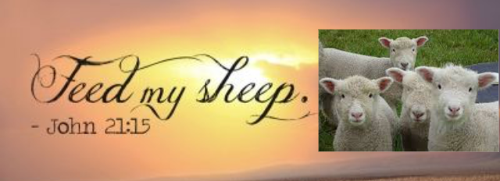

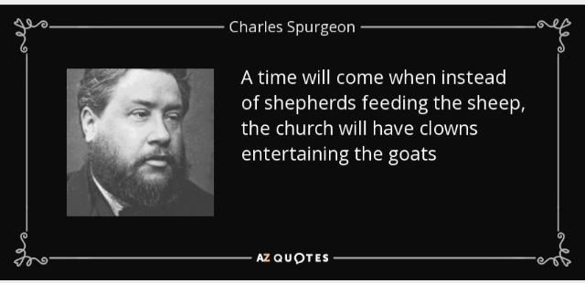

May God Bless and Keep my Readers!!

