PARABLE OF THE SOWER
WRITTEN BY: TOMMY ROMANS MARCH 2017

In this Newsletter, I want to deal with the Parable of the Sower. In Mark’s Gospel, chapter 4:1-25, Jesus comes preaching and teaching the Word of God. In doing so, He is sowing the Heavenly Seed upon the ground of man’s heart. Why is He sowing the Seed? Because He is desiring a harvest. We must realize in this parable, there’s nothing wrong with the Sower, and there is definitely nothing wrong or slack in the Seed. So where’s the problem? Where does the fault lie? It’s in the Heart of man! God has given us His written Word, inspired by the Holy Ghost. Thank God, our Bible is the Word of God, the Holy Seed! He has sent His prophets, apostles and ministers to teach and preach it to every generation. Why? He is seeking to get the Word of God into every heart. He wants a Harvest of Souls to get them ready for the Kingdom of Heaven and eternity!

FOUR DIFFERENT TYPES OF GROUND
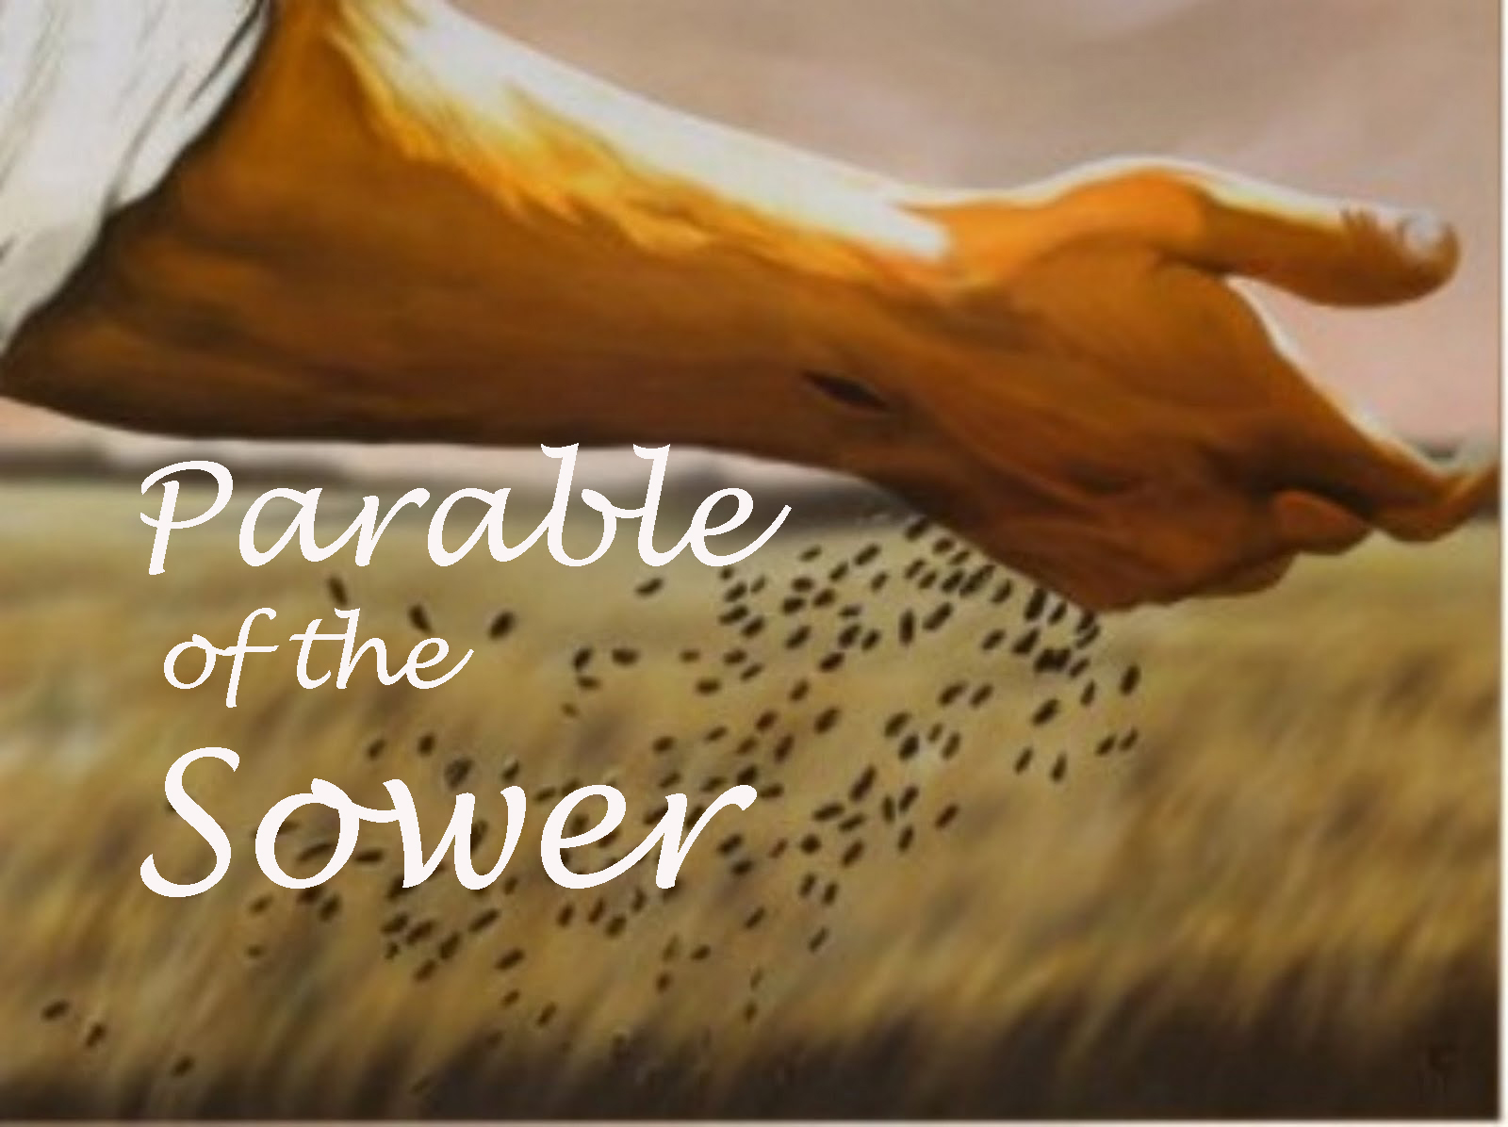
In this Parable, there are 4 different types of soil or ground within the Heart of man. Out of these four, only one of them is Good! One of them will produce and bring forth fruit. Three of them are too bad to grow anything. Every person in this world will fit in one of these 4 categories: In the first three categories we learn why the Seed can’t and won’t grow, why the Word of God won’t bring forth fruit unto harvest. In this Parable, not much is said about the Sower or the Seed – they are Perfect! The focus is entirely upon the Ground. The Lord concentrates upon the condition of man’s Heart.

THE FIRST CATEGORY -
“WAYSIDE GROUND”

The first type of ground Jesus teaches about is the Wayside soil! Mark 4:1 ¶ And He (Jesus) began again to teach by the sea side: and there was gathered unto him a great multitude, so that he entered into a ship, and sat in the sea; and the whole multitude was by the sea on the land. 2 And he taught them many things by parables, and said unto them in his doctrine, 3 Hearken; Behold, there went out a sower to sow: (Listen, take Heed)

4 And it came to pass, as he sowed, some fell by the Way Side, and the fowls of the air came and devoured it up. 15 And these are they by the Way Side, where the Word is sown; but when they have heard, Satan cometh immediately, and taketh away the Word that was sown in their hearts.
In this first category, the Sower, (preacher) sowed the Seed – the (Word of God) and it fell by the Way Side. I asked the Lord in prayer to reveal what He was saying here. With much study and digging into the history at that time I discovered that the Way Side soil is the Hard ground beside the furrows which had been packed down by the feet of farmers, travelers and passersby. Palestine at that time had no fences separating their fields and gardens. Most people traveled by foot. In their visits and business ventures, they would cut across the fields crisscrossing the ground all over until it became hardened. Yes the soil in the fields had been tilled, cultivated and laid off in furrows ready for the Seed, but if that Seed didn’t make it into the soft soil down inside the furrow but fell on the hard packed ground beside it, then it would never germinate and grow. That precious Seed would lay on top of the hard ground and fall prey to the fowls which would devour it up. This is the Way Side soil trampled and hardened by the feet of others.
Dear Jesus, what are you telling us here? Remember, Jesus said to the great multitude who had gathered – Hearken, Behold – Listen to me and take notice! Don’t let the ground of your Heart become too hard for the Word of God to enter. This is where many people are today. The Word of God cannot find its mark in their soul, cannot find a lodging in their hearts because the ground of their heart has been hardened by the feet of others who have walked across their lives and left them hardened. Listen, we all know by experience and have witnessed it through the years even in the lives of others that people come and go - friendships are made and friendships are broken. Fellowships are made and fellowships are broken. Business deals fall through. When dealing with others, many things can happen. It happens in families as well as Church’s. The passing of people in and out of your life can harden you if you let it. God never created our feet to walk on others, but to walk a path of humility and obedience with others’ welfare at the center of our Hearts. That Golden Rule still reigns today – “Do unto others as you would have them do unto you.”
Listen dear soul, during your lifetime you will have people who will walk right into your life, stay for awhile and when they depart they leave behind them bad experiences that become hard to deal with. They leave heart break and disappointment. So many people in this world are used and abused and taken advantage of, but Jesus will tell you – “don’t ever let your heart become hard to the point that God’s Precious Word cannot bless or bear fruit in you! People will walk across your fields and the garden of your heart with their words and deeds.” There will be hurts and wounds but don’t ever let it harden you toward precious souls Jesus died for. What are you saying to us your children Jesus? Be careful in your dealings with people. Be very careful before sinners. Mic 6:8 He hath shewed thee, O man, what is good; and what doth the LORD require of thee, but to do Justly, and to love Mercy, and to walk humbly with thy God?
You can do and say things that will harden people that God is trying to reach. It is sad to see Christians who do not see the eternal value of souls that Jesus is reaching for. If we don’t watch and pray, we become too loose and careless and end up hurting others. My prayer is: “Lord, please let me be True and Faithful to you and live Honest before others! Let my dealings be Just and Righteous before the eyes of all. Please don’t let me do anything in any way by my actions, words or deeds to offend and hinder people from coming to you!” God forbid that I would be dishonest in money matters and not pay the debts I owe. I don’t want to live a lie or deal falsely that would cause the Gospel of Christ to never find its lodging place in the hearts of sinners and backsliders. We must walk in wisdom toward them that are without – sinners. Don’t let your good be evil spoken of. We must Keep our word, the promises and Commitments we make – people are watching, their eyes are on the Church. Let’s be Faithful in God’s Service!
I want to say again – we will all face circumstances that will try us. We all will have let downs and failures in life, but remember – there is nothing wrong with Our God – He is Perfect, Faithful and True. His precious Word is the eternal Seed given to us by the Holy Ghost. When it finds its way into the good soft ground of your Heart, it will always bring forth fruits of Righteousness and a harvest of souls! Hos. 10:12 Sow to yourselves in righteousness, reap in mercy; break up your Fallow ground: for it is time to seek the LORD, till he come and rain righteousness upon you. What’s God saying? Break up your hard ground and make it soft for the Seed to be sown. When we humble ourselves and seek the Lord, we are allowing Him to till the ground of our Heart and prepare it for His work of Grace that we might be a shining light to Save others.

THE FOWLS OF THE AIR

Notice what Jesus said in Mark 4:4 – The Seed that fell on the Way side, the fowls of the air came and devoured it up. Don’t forget, Satan hates the Word of God! He hates the Sower, he hates the preacher and teacher. He does not want that Seed to get inside the heart and grow. He doesn’t want people saved, delivered and filled with the Holy Ghost. He doesn’t want the Lord’s people Blessed and used. If he can, he will remove that precious Word. He will get you occupied with other things and rob you of that Holy Seed. He’ll take the Message away. The devil never wants the Word of God to take root in your life and bring forth righteous fruit. So what’s he do? He sends many things to harden you in mind and Heart. These fowls here in this parable represent the evil spirits at work to cause hindrances and distractions. People hear the message, they hear the preacher but their minds and affections are somewhere else.
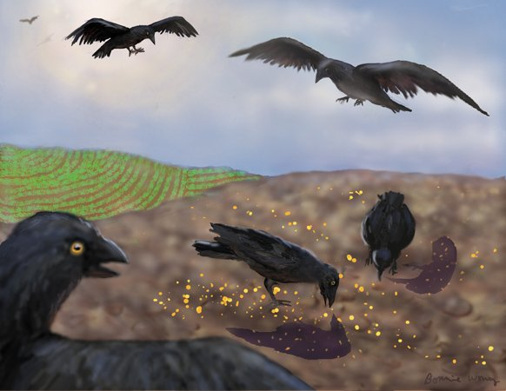

Listen, the unseen Powers of Darkness are busy at work in homes and in Church’s to take people’s minds away from God. If you could tune in and see into the spirit realm in a Church service, you would hear the fluttering wings of Satan’s fowls and see them devouring the Seed as the minister preaches. These fowls sit on the shoulders of people to catch the Word and take it away. The reason? Because hearts are hardened by worldly associations, daily activities and socializing. There is no time for God. People spend no quality time with Him in Prayer or in His precious Word. Their Bible remains closed and the ground only becomes too hard for God to speak and deal! The Word will never penetrate. Oh dear soul that is out there somewhere, the Anointed message cannot make an impression on you – your Heart has become Hard. In ending this first category, thousands heard Jesus that day long ago and went away unaffected, went to their grave barren and unsaved. Don’t let your Heart become Way Side ground. Don’t allow this world or people Harden you! Always remember, Jesus is just as Good and Sweet, Loving and Forgiving as He ever was – He has not changed!! Thank God! His Word has never lost its effectiveness. It still has power to save and transform lives. It restores and it Heals. It brings forth the best fruits. For when the Lord returns – He will look for a Harvest. So get that Holy Heavenly Seed in your Heart and let God Bless you!!!

THE SECOND CATEGORY
“STONY GROUND”

Mr 4:5 And some (Seeds) fell on Stony Ground, where it had not much earth; and immediately it sprang up, because it had no depth of earth:
6 But when the sun was up, it was scorched; and because it had no root, it withered away. Mr 4:16 And these are they likewise which are sown on stony ground; who, when they have heard the word, immediately receive it with gladness;
17 And have no root in themselves, and so endure but for a time: afterward, when affliction or persecution ariseth for the word's sake, immediately they are offended.
A lot of people fall into this category – thousands, even millions! They won’t be able to endure and stand when trials and hard times come because they didn’t go deep enough. To this group, the Word was Preached also – they heard it and even received it with joy. The Seeds immediately sprouted and shot up with promise. But there was only one problem, there wasn’t much soil because the ground was mostly stones – too many stones and no depthness of good soft soil to work with. Their experience and victory was short lived – Why? Because the ground was filled with rocks – stones of hindrance. The roots could not go deep to take good root. God surely looks down and He sees below the surface and deep into our hearts. All this second category of ground had in it was mostly rocks. Stones speak of Pride and Self-will, a stony heart that is not humble but rough in nature, a character that is unyielding and hard to get along with, a disposition that refuses to pray and let God work on it to change it.
We live in a stony age, a generation that is hard hearted toward God and others. The Lord knows where the troubled spots are in our life. To have the Lord to prosper us and have His precious Word to work for us and be blessed, we must get every stone of stubbornness and pride out of the ground of our heart. If we don’t we will never bear the good fruits of Righteousness. We must get control of our bad attitudes and hard dispositions. What are some of the stones of hindrance we run into? Stones of anger and temper, stones of ill-will and bitterness, stones of grudge and unforgiveness. These are the hard places in our life the Holy Ghost will deal with. The Lord is telling us that fiery trials and afflictions are going to come and we must go deep to endure. Our roots must go deep enough in the rich soil to hold us in these times of trouble and hardships. Just an inch or two of soil is not enough to hold us. I have seen many through the years come and go. These people had good intentions. They heard the message, was convicted of their sins, the Holy Ghost drew their hearts and God’s love captured them. They prayed and told God they were sorry. They started coming to Church, prayed at the Altar, humbly cried at the songs and clapped their hands. They were happy and sincere until trouble came. Jesus said the sun scorched them and they soon withered and died spiritually. Why? Because they never prayed deep enough to remove the hard stones of hindrance out of their life, that lay below the surface!
Listen, many of God’s people come to Church and they are faithful but they have no true joy or power. They could do much more for God but beneath their little layer of soil are stones that will not yield up their place. Many have carried these stones for years. Their life is a story of ups and downs – they never went deep to remove the rocks and they so easily withered at the least hint of temptation and trouble. Jesus is dealing with man’s heart in this Parable.
Down through my almost 43 years of serving God, I’ve had to deal with many stones. When this once bound in sin drug addict and worldly sinful soul came to Jesus, His Love and Mercy captured my Heart. My new found love of Jesus conquered my very Soul – it motivated me on. I burnt many bridges behind me as I went, I’ve cut the cords of the old life and left it behind. Many times I’ve had to wallow the Altar and cry out to God to help me and take things out of me that didn’t belong, things that hindered and held me back from victory. I’ve had to make sacrifices along the way and sacrifices always involve pain. You have to say – Lord, not my Will any more, but I want your Will to be done in my life.
I’ve been preaching and teaching Sunday School now for 38 years. I’ve seen many come to the Altar, watched them pray through to victory. I witnessed the Holy Ghost touch and bless them. I watched them get up with a glow on their face, their heart was soft, love flowed from them, they got the Stones out of the way and they went on with Jesus and was a blessing to others and did a great work for God. I saw a young man come to the Lord, give his whole heart and life to Him. He had such a hunger for God! He cried and prayed for a closer walk and to be filled with the Holy Ghost. He would pray service after service at the Altar until he was wet with sweat. I watched him lay in the floor and pray so hard and so long that when he got up, the floor was wet from the sweat of his body. Today this man is a great blessing to many, his light shines for God and is a great testimony. He left the world far behind, got all the stones out of the way and now he stands tall for his Lord, rooted and grounded in the faith and is truly a pillar in the Church. O what a Christian, bearing the image of Christ as He works for God! You hardly see this anymore! People would rather hold on to the world and their self will.
On the other hand, I’ve seen many others come to the Altar under conviction, the preached Word of God dug them up, the Holy Ghost dealt with them about things in their life that needed dealt with. In God’s divine presence, they saw hard places and stones in their heart that needed uprooted and gotten rid of. I would watch them pray right up against a rock so to speak, prayed right up against their hindrance and you could tell they didn’t get through – they weren’t willing to surrender to God and give it up and you could see the Spirit of God lift. They would get up with the same stone face and go back to their seat miserable and without victory. The Seed of the Precious Word of God could not enter their Heart, could not grow and bear fruit because of the Stony Ground! They went back home to their family unchanged and ended up going back to the same old crowd in the same old shape as before. Later on you would hear they went down in defeat!
Listen children, I have witnessed many families, marriages, homes and lives shattered and torn apart because people never prayed hard enough to remove the Stones in their life! God was there to help them and give them victory, but they weren’t willing. Now their lives are a horrible mess!!
Jesus said plainly, these people in the second category of the Stony Ground had no root in themselves! I can see Jesus that day as He sat in the boat looking into all the faces of the people standing on the shore. He knew His Words would fall on Wayside ground and on Stony Ground and many of those people would walk away and miss God, would never have His blessings in their life. They would miss eternal life and would end up being prey for the devil. Satan would destroy them because they had no fixed principles in their judgments, no convictions in their hearts. What they felt in Jesus’ presence is good, but it’s only on the surface. Many would not remove the stones and let the Word of God take good root in their life. Jesus looks today and sees multitudes walking away. They felt His divine Love and presence, but they won’t dig deep enough and prepare the ground of their Heart to receive the Precious, Good Holy Word of God that will Save and Sanctify them and give them Eternal Life! Soon, Jesus will come, He will send His reapers (the angels) and He will gather His wheat into the garner but the tares and the chaff will be burned. The fields of this world will be harvested. God will look for fruit in the lives of His children. Will He find you bearing good fruit? Will He find His Word growing in your Hearts and bearing the fruits of Righteousness and Holiness? He’s looking for the Good Ground of the Heart that is yielded to Him, soft, cultivated and clean, free from stones and hard things.
In the first category, we dealt with Wayside Ground that becomes hard by the feet of passing people in our lives that harden us to the good things of the Lord and His Word will never sprout up in our Heart in Salvation and Blessing! We let others stand between us and Victory. And now we close with the Stony Ground of our Heart where we don’t conquer hard things and personal things in our life that we need victory over! We can let attitudes develop if we don’t pray and stay humble before God. The old sinful, carnal nature will take over and we soon Spiritually wither and die. There’ll be no fruit to offer God on the Judgment Day!
As I close, my heart is touched within me. Many of God’s people are going through it. We live in an evil pressing time, the trials and afflictions are many. The Love of many is waxing cold in this world. We must Pray – Pray and Keep our Hearts humble before God. Don’t drift, don’t become cold and indifferent. It’s no time to let up. Don’t let things harden you, Jesus in nigh, even at the door! Can you remember when Jesus first Saved you and came into your Heart? O that good feeling you had! It’s called the First Love when our whole life was changed and everything became new. We shined for Jesus! Our Salvation held its newness and excitement. We couldn’t hold back but went running with the Good News and burnt the bridges behind us. We couldn’t wait to tell others about our new found Love and how good God is. Hey, Jesus saved me, He filled me with the Spirit! But now the months and years have passed. Troubles and trials have come. Can I ask you – does your Salvation still hold its newness and excitement? It’s like your very first new Car. You kept it clean and shined, wouldn’t let any dirt on it. You wanted everybody to see that new car, you felt so good in it going down the road. But after a few months you lose interest and start letting it go. Now we can let dirt and mud get on it and it doesn’t even bother us anymore. O Lord, help us all to always keep the Love of God in our Hearts and keep shining for Jesus! May God Bless my readers!

